1. PHOTOSHOP
If you’re good with post-processing and manipulations, use it to your advantage. Get crazy with the adjustments, try some new Photoshop techniques, and maybe even a composite image.
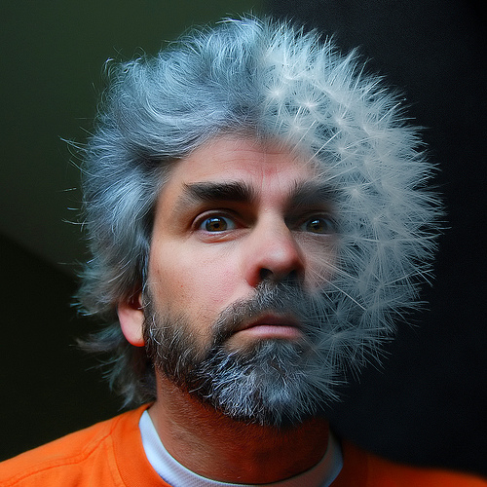
Photo by Paul Moody [CC by-nc]

2. TEXTURE
If texture is a big part of your subject, make it stand out and make it obvious. Match up the textures between your subject and your background. You might even try texturizing the entire photo for additional impact.
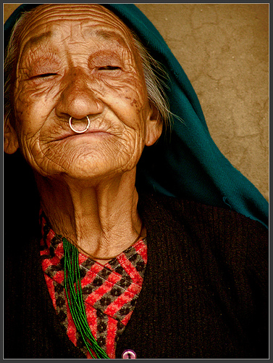
Photo by Sukanto Debnath [CC by]

3. OVEREXPOSE
Blowing out the highlights or making a high-key image makes a nice soft portrait with kind of a light airy feeling. Another advantage of high-key photos is that the smaller details and defects are blown away, making the image look much smoother.
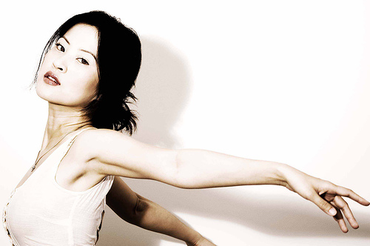
Photo by sam_samantha [CC by-nc-sa]

4. UNDEREXPOSE
A dominantly dark or low-key image will naturally draw your eyes to the lighter parts. These tend to have a grittier and harder look to them than the high-key images.
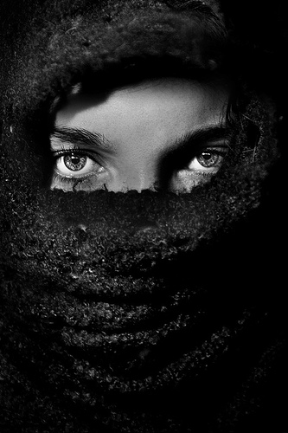
Photo by ConfusedVision [CC by-nc-nd]

5. BACK-LIGHT
Hair lights up like crazy when it’s back-lit, so if hair is a big part of your subject make it stand out by placing your subject between you and a light source. You could also take this a little further and push the image to a silhouette.
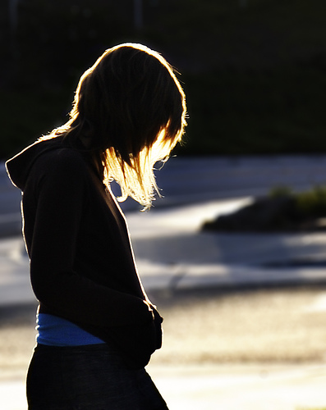
Photo by Caleb Sconosciuto [CC by-nc-nd]

6. POSING
Get crazy with the pose and positioning — extra points if it looks uncomfortable. Not only with the poses, but also with your own positioning — shoot from different angles to achieve different impacts.
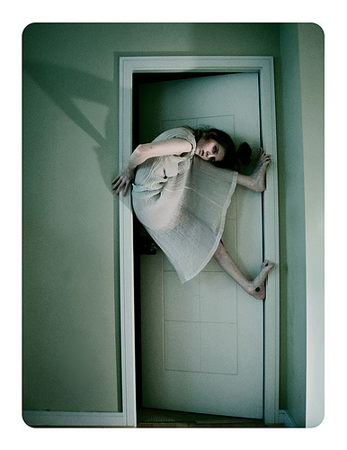
Photo by Socar Myles [CC by-nc-nd]

7. CULTURE
Capture the local culture — what’s mundane to you is exotic to us. Culture is everywhere, even in your own town. Just image you’re visiting from a different country — what things would then seem more interesting to you?
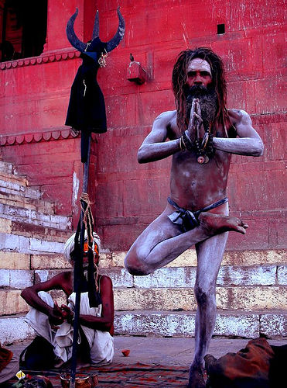
Photo by vodkamax [CC by-nc-nd]

8. REFLECTIONS
Make use of different surfaces to add that extra dimension — windows, mirrors, and water are all very good reflective surfaces that give a different result and texture.
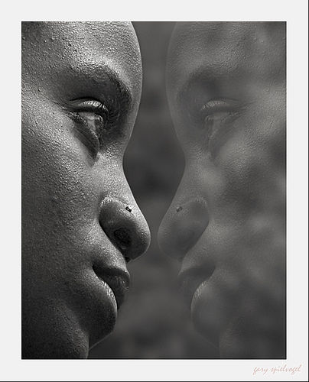
Photo by Gary H. Spielvogel [CC by-nc-nd]

9. SHADOWS
Make the shadow an important part of the image. Sometimes the shadow can even be more prominent than the actual subject casting the shadow.
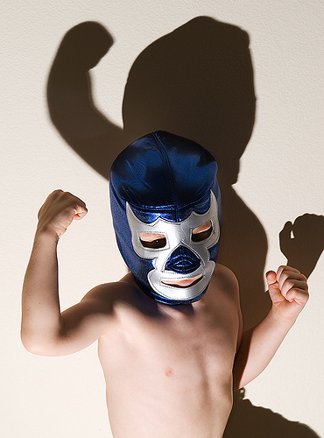
Photo by Brian Auer [CC by-nc-nd]

10. GET CLOSE
There’s no rule against cropping out most of the subject’s face. This draws more attention to the parts that are left in the frame.
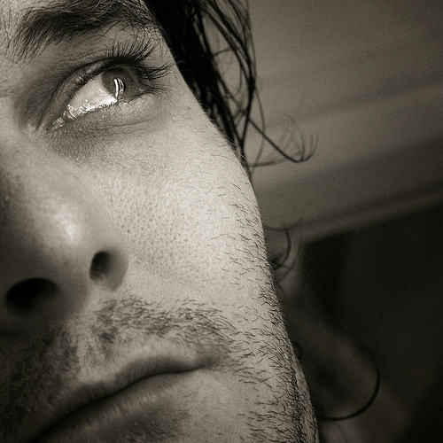
Photo by Phil Hilfiker [CC by-nc-nd]

11. (UN)FOCUS
Out-of-focus subjects can be more interesting than the in-focus subjects. It kind of adds some mystery to the image because you can’t quite make out who that person is.
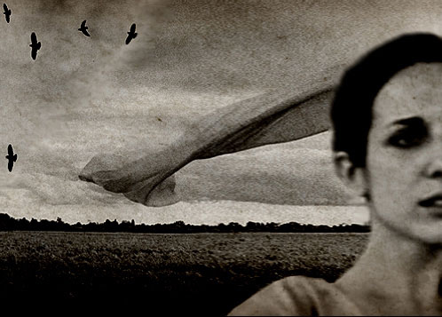
Photo by a bout de souffle [CC by-nc-nd]

12. MOVEMENT
Use movement to show action, even if it blurs out the subject entirely. In cases like this, think of the person as a means of creating the subject rather than being the actual subject.
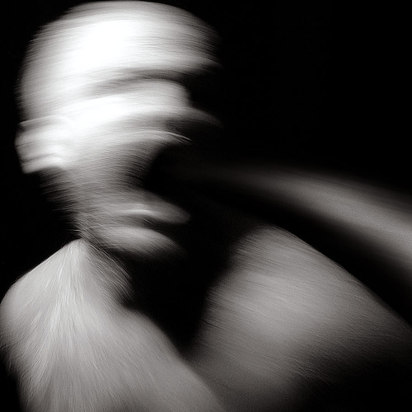
Photo by ArtWerk [CC by-nc-nd]

13. CAPTURE THE MOMENT
Catch somebody doing something they love, even if it’s not staged. Street photography is one of my favorite genres because it captures life as it happens — unstaged and unposed.
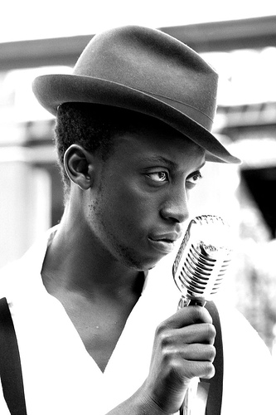
Photo by Mireia [CC by-nc-nd]

14. COLORS
Use vibrant and contrasting colors to draw attention to parts of your subject. This could be makeup, clothing, accessories, or whatever else you can get your hands on.
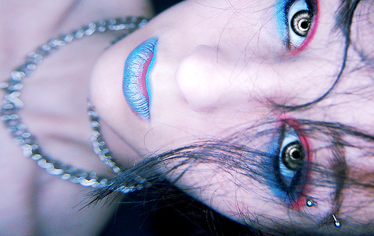
Photo by TNT Photo [CC by-nc-nd]

15. GET SERIOUS
Not all portraits need to have a smile, capture the serious emotions too. Some of my favorite portraits have no hint of a smile in them, and they’re highly emotional.
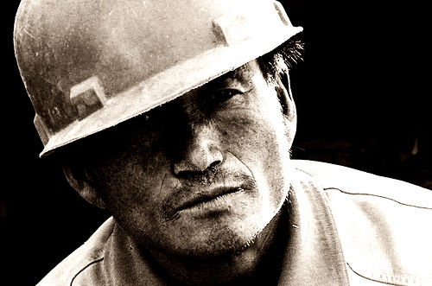
Photo by Saad Akhtar [CC by]

16. PROPS
Use the props and tools around you to make the setting more interesting. Find things to place your subject in, on, under, around, etc.
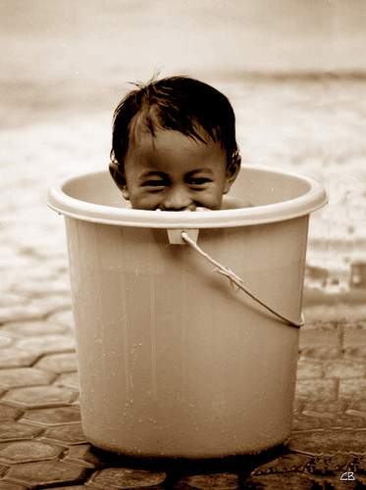
Photo by Bachellier Christian [CC by-nc-nd]

