BASIC PHOTOGRAPHIC TECHNIQUES
Today, photography is characterized by a rapid growth in the development of technology and ideas. Each year, millions of pictures are taken and an astonishing array of new films, cameras and imaging systems enter the market. One of the great attractions of the photography field is the ease with which basic skills can be learned.
Unlike some of the older arts that take years of training to produce an acceptable product, anyone can quickly learn how to take a picture; however, photographic techniques must be mastered before you can become an accomplished photographer; therefore, mastery of the basic fundamentals is the foundation upon which you will build your photographic and professional skills as a Navy Photographer’s Mate. The photographic techniques presented in this chapter are essential in producing quality photographs, and you can apply each of these fundamentals, to some extent, each time you take a picture.
Lesson 1: Photographic Composition, Center of interest, Subject placement, Simplicity, Viewpoint and camera angle, Balance.
Lesson 2: Shapes and lines.
Lesson 3: Pattern, Volume, Lighting, Texture, Tone.
Lesson 4: Contrast, Framing, Foreground, Background.
Lesson 5: Perspective.
Lesson 6: Basic lighting techniques: Outdoor and Existing ligt photography.
Lesson 7: Composition and Basic shots or sequences.
Appendix: Subject and Rule of Thirds.

PHOTOGRAPHIC COMPOSITION
Photographic composition is the pleasing arrangement of subject matter elements within thepicture area. Creative photography depends foremost on the photographer's ability to see as the camera sees because a photograph does not reproduce a scene quite the way we see it. The camera sees and records only a small isolated part of the larger scene, reduces it to only two dimensions, frames it, and freezes it. It does not discriminate as we do. When we look at a scene we selectively see only the important elements and more or less ignore the rest. A camera, on the other hand, sees all the details within the field of view. This is the reason some of our pictures are often disappointing. Backgrounds may be cluttered with objects we do not remember, our subjects are smaller in the frame or less striking than we recall, or the entire scene may lack significance and life.
Good pictures are seldom created by chance. To make the most of any subject, you must understand the basic principles of composition. The way you arrange the elements of a scene within a picture, catch the viewer’s attention, please the eye, or make a clear statement are all qualities of good composition. By developing photographic composition skills, you can produce photographs that suggest movement, life, depth, shape, and form, recreating the impact of the original scene.
How are photographic composition skills developed? You look, you study, you practice. Every time you take a picture, look all around within the viewfinder. Consider the way each element will be recorded and how it relates to the overall composition. You must become thoroughly familiar with the camera and learn how the operation of each control alters the image. Experiment with the camera and look at the results carefully to see if they meet your expectations. With experience and knowledge of your equipment, you begin to "think through your camera" so you are free to concentrate on composition. Devote serious study to the principles of good composition. Study books and magazine articles on composition. You should analyze various media: motion pictures, TV, magazines, books and newspapers, and evaluate what you see. What is good about this picture or that TV image? What is bad about it? What principles of good composition could you apply in a different way to make the picture better.
Good or correct composition is impossible to define precisely. There are no hard-and-fast rules to follow that ensure good composition in every photograph. There are only the principles and elements that provide a means of achieving pleasing composition when applied properly. Some of these principles and elements are as follows:
- Center of interest  - Subject placement  - Simplicity  - Viewpoint and camera angle  - Balance  - Shapes and lines  - Pattern  - Volume | - Lighting  - Texture  - Tone  - Contrast  - Framing  - Foreground  - Background  - Perspective
As you study these principles of composition, you should soon come to a realization that some are very similar and overlap one another a great deal.
Because all or most of these principles must be considered and applied each time you take a picture, it may all seem quite confusing at first. With experience you can develop a sense of composition, and your consideration and application of the principles will become almost second nature. This is not to suggest that you can allow yourself to become complacent or careless in the application of the principles of composition. Doing so will be immediately obvious because the results you produce will be snapshots, not professional photographs.
The principles of composition that follow apply equally to both still and motion media photography.

CENTER OF INTEREST
Each picture should have only one principal idea, topic, or center of interest to which the viewer's eyes are attracted. Subordinate elements within the picture must support and focus attention on the principal feature so it alone is emphasized.
A picture without a dominant center of interest or one with more than one dominant center of interest is puzzling to a viewer. Subsequently, the viewer becomes confused and wonders what the picture is all about. When the picture has one, and only one, dominant "point of interest," the viewer quickly understands the picture.

NOTE:
"Point of interest," as used here, has the same meaning as center of interest; however, using the term point of interest prevents giving the impression that the center of interest should be located in the center of the picture.
The specific topic, idea, or object to be portrayed must be set in your mind as you prepare to take a picture. When there is nothing in the picture to attract attention to a particular area or object, the eyes wander throughout the scene. The center of interest may be a single object or numerous ones arranged so attention is directed to one definite area
When the center of interest is a single object that fills most of the picture area or one that stands out boldly, such as a white sail against a background of dark water, attention is attracted immediately to it. As may be expected, not all subjects are as simple to arrange or as bold and impressive.
A photographer usually has at his or her disposal many factors or elements that can be used and arranged within the picture area to draw or direct attention to the primary idea of the picture. Some of these elements are lines, shapes, human figures, tone, and texture.
Human figures attract attention more strongly than almost any other subject matter and unless they are the main object of the photograph should probably be kept out of the picture; for instance, a photograph showing a person standing at some distance in front of a building may leave the observer wondering whether the person or the building is the primary subject. When people are included in a scene for comparative size of objects or just for atmosphere, keep them from looking directly at the camera. When people look at the camera and therefore at the viewer of the picture, the viewer tends to return their gaze by looking directly back into their eyes. When they are not the intended point of interest, we miss the statement and purpose of the picture. When people are subordinate elements within the picture and they are looking in a direction other than at the camera, the viewer’s attention is directed from the people to what they are looking at, which should be the center of interest; for example, when people are grouped around a piece of machinery that is the center of interest of the picture, have them look at the machine, rather than the camera.
SUBJECT PLACEMENT  Sometimes good composition is obtained by placing the center of interest in the geometrical center of the picture; it is generally not a good idea to place it there. Too frequently it divides the picture into equal halves and makes the picture uninteresting and difficult to balance. By dividing the picture area into thirds, both vertically and horizontally, and locating the center of interest at one of the intersections of the imaginary lines, you can usually create a feeling of balance to the composition (fig. 5-5). | 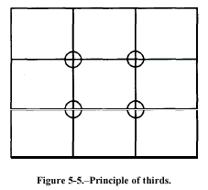
In photographic composition there are two general guides for determining the best location for the center of interest. The first is the principle of thirds. The other is dynamic symmetry. In the principle of thirds, the intersection of lines that divide the picture area into thirds are marked by O’s. These intersections are good locations for the center of interest in most photographs. Notice we said THE center of interest. Remember, have only one center of interest to a picture-keep it simple. The principle of dynamic symmetry is a similar idea. A good location for the center of interest is found by drawing or imagining a diagonal line from one corner to an opposite corner. Then, draw a second line perpendicular to the first from a third corner (fig. 5-6). The intersections of the lines are the location for the center of interest. | 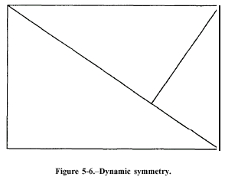

SIMPLICITY
Simplicity is the key to most good pictures. The simpler and more direct a picture is, the clearer and stronger is the resulting statement. There are several things to be considered when we discuss simplicity. First, select a subject that lends itself to a simple arrangement; for example, instead of photographing an entire area that would confuse the viewer, frame in on some important element within the area. Second, select different viewpoints or camera angles. Move around the scene or object being photographed. View the scene through the camera viewfinder. Look at the foreground and background. Try high and low angles as well as normal eye-level viewpoints. Evaluate each view and angle. Only after considering all possibilities should you take the picture. See beyond and in front of your subject. Be sure there is nothing in the background to distract the viewer's attention from the main point of the picture. Likewise, check to see there is nothing objectional in the foreground to block the entrance of the human eye into the picture.
A last point of simplicity-tell only one story. Ensure there is only enough material in the picture to convey one single idea. Although each picture is composed of numerous small parts and contributing elements, none should attract more of the viewer's attention than the primary object of the picture. The primary object is the reason the picture is being made in the first place; therefore, all other elements should merely support and emphasize the main object. Do not allow the scene to be cluttered with confusing elements and lines that detract from the primary point of the picture. Select a viewpoint that eliminates distractions so the principal subject is readily recognized. When numerous lines or shapes are competing for interest with the subject, it is difficult to recognize the primary object or determine why the picture was made.

VIEWPOINT AND CAMERA ANGLE
The proper viewpoint or camera angle is an important factor in good composition. Repositioning your subject within the viewfinder frame and changing the camera viewpoint or camera angle are two simple ways of controlling composition.
Photographing from a different viewpoint or camera angle can often add drama and excitement or even bring out an unusual aspect of a subject. Most of the subjects you photograph are three-dimensional and should be photographed from an angle (to the right or left of and/or from higher or lower than the subject) that allows the viewer to see more than one side of the subject. The photographer should study the subject from different sides and angles. Walk around the subject and look at it from all viewpoints. See it from elevated and low positions as well as from eye level to find the best composition. This greatly assists in composing the subject for the best balance and helps to select a background that compliments, not distracts from the subject.
The terms viewpoint and camera angle are often used in conjunction with one another and sometimes used interchangeably. They can also have different meanings depending on how they are applied. Viewpoint" is the camera position in relationship to the subject. "Camera angle" is the angle in which the camera lens is tilted; for example, a picture of sailors marching, made from ground level with the camera held horizontal with reference to the ground, may be referred to as a "low viewpoint" (or camera position); however, when this picture is made, again from ground level, but with the camera pointed up, it may be referred to as a "low camera angle." Likewise, a picture made from an elevated or high position, with the camera again held horizontal with reference to the ground, or even pointed straight down, can be referred to as a "high viewpoint"; however, if the camera is not held horizontal to the ground or pointed straight down, but pointed at some angle between horizontal and vertical, the camera position could be referred to as a "high camera angle."

Eye-Level Shots
With the camera held horizontal, eye-level shots are usualIy made at a height of about 5 1/2 feet, the height from which the average adult sees, and with the camera horizontal. With the camera held at eye level but pointed up or down, the camera position changes and you have either a low or high camera angle, respectively.
Low Viewpoint and Low Camera Angle  Low viewpoints and low camera angles can add emphasis and interest to many ordinary photographs. A low viewpoint can be used to distort scale or add strength to a picture or to emphasize certain elements within the picture. A low camera angle is achieved when the camera angle is located below the point of primary interest and pointed upward. Low angles tend to lend strength and dominance to a subject and dramatize the subject. Low angle shots are used when dramatic impact is desired. This type of shot is very useful for separating the subject from the background, for eliminating unwanted foreground and background, and for creating the illusion of greater size and speed (fig. 5-7). | 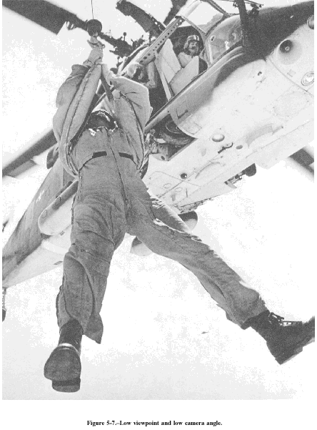
High Viewpoint and High Camera Angle  High viewpoints and high camera angles help orient the viewer, because they show relationships among all elements within the picture area and produce a psychological effect by minimizing the apparent strength or size of the subject (fig. 5-8). | 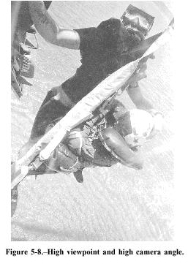

BALANCE
Balance in photographic composition is a matter of making pictures look harmonious. Each element in a picture has a certain amount of value in respect to all the other elements. Every tone, mass, shape, tree, rock figure, building, line, or shadow contributes a certain amount of weight that must be arranged correctly in the composition to give the impression of balance. The subject placement within the picture area is the factor that must be carefully considered.
Composition is kept in balance by two different methods: symmetrical, or formal, balance and asymmetrical, or informal, balance.
Symmetrical, or Formal, Balance  Symmetrical, or formal, balance in a photograph is achieved when elements on both sides of the picture are of equal weight (fig. 5-9A). The idea of formal balance can be related to a seesaw, When there are two equally weighted objects on the seesaw and they are equidistant from the pivot point, or fulcrum, the board will be in balance.  Pictures with formal balance may look static and unexciting; however, they do present an air of dignity. Formal balance does not always mean a picture has to the seesaw in perspective. The forces or weights are be symmetrical. Symmetrical pictures, in which both presumed to be approximately equal; but, the imaginary sides are exactly the same, are produced only when you pivot point is set deep into the picture space. With this want a special effect; therefore, they are not often variation to symmetrical balance, a more interesting produced. A variation of symmetrical balance deals with photograph is usually created (fig. 5-9B). | 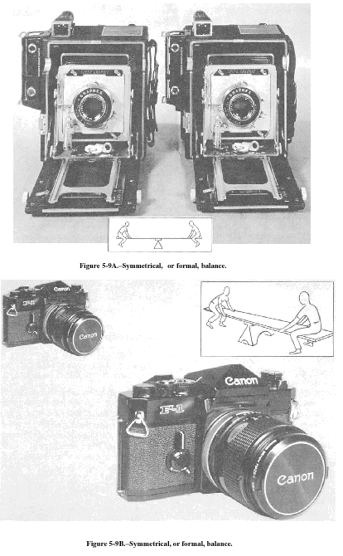

Asymmetrical, or Informal, Balance
Asymmetrical, or informal, balance is usually much more interesting than symmetrical balance. In asymmetrical balance the imaginary central pivot point is still presumed to be present; however, instead of mirror images on each side of the picture area, the subject elements are notably different in size, shape, weight, tone, and placement. Balance is established by equalizing the element forces in spite of their differences.
Asymmetrical balance is introduced when the presumed weight of two or more lighter objects is equalized by a single heavier object placed on the other side of the imaginary pivot point (fig. 5-10). Asymmetrical balance is more difficult to achieve than symmetrical balance, because of the problem of establishing relative weight values for dissimilar elements within the picture area as well as presenting some form of stability.
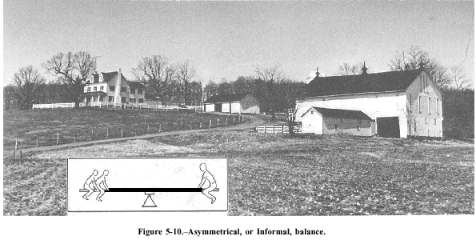

Aspects of Balance
There are many other factors to consider in order to make pictures appear balanced. Some of these are as follows:
- An object far from the center of the picture seems to have more weight than one near the center.
- Objects in the upperpart of a picture seem heavier than objects of the same size in the lower part of a picture.
- Isolation seems to increase the weight of an object.
- Intensely interesting objects seem to have more compositional weight.
- Regular shapes seem to have more weight than irregular shapes.
- Elements on the right side of an asymmetrical picture appear to have more weight than elements of the same size on the left side of the picture.
- The directions in which figures, lines, and shapes appear to be moving within the picture area are important to balance; for example, a person may be walking in a direction, or his eyes may be looking in a direction, or the shape of some element creates a feeling of movement. When the feeling of direction is present within a scene, it tends to upset the balance if judged on the size of the subject alone.
Understanding the factors required to create pictorial balance is essential for you to produce good pictures. To gain this understanding, you can continually test your feelings for balance as you look through your camera viewfinder. Once you gain an understanding of the principles of pictorial balance, achieving balance in your photographs becomes an easy process.

