Photography Techniques & Tips
Introduction to Night Photography  Just when the sun has set and you thought it was safe to go back to the couch after a hard day of shooting, suddenly night falls and a whole new world of subjects is illuminated. From the jack-o-lanterns on your neighbor's front step to the bright lights of Broadway to the neon signs at the local diner, the night is full of color and light and all you need to capture it is a tripod, a lot of memory card space and a pioneering spirit.  Finding nighttime and low-light subjects is pretty easy and even ordinary things you might not notice during the day can become quite interesting after dark--simple things like walk lights and even the local fast food joint are all worthwhile design ideas. If you want to get a little more adventurous and add motion to the nighttime mix, things like traffic patterns and carnival rides can turn into extraordinary images when combined with a long exposure. In summertime, almost every town and city has an annual fireworks display that provides great opportunities for night shots. And if you're really ambitious, you can create your own light and motion pictures with things like sparklers or flashlights.  In the tutorials below I'll introduce you to some of the very simple tips & techniques involved in shooting pictures after dark and I'll also talk about the specifics of some common after-dark subjects. To learn a lot more about night exposures and all types of exposures, be sure to see my new bestselling book Exposure Photo Workshop (Wiley; 2008).
  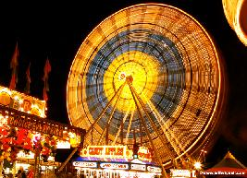
  Ferris Wheel at Night
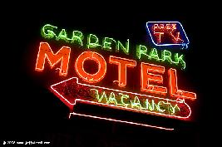
Neon Motel Sign

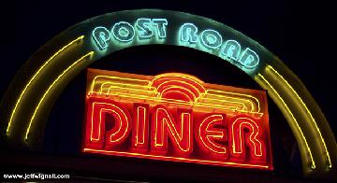
Neon Diner Sign, Norwalk, Connecticut

Become a better and more creative photographer in just 30 seconds a day! Visit my new PHOTO TIP OF THE DAY blog! Each day I post a new quick tip that will make your photos stronger and more interesting.

 | Basic Consideration: High ISO vs. Long Expoures?  Almost every time I take a night or low-light photograph I ask myself the same question: Should I use a longer exposure time and keep the ISO low to get better image quality, or should I raise the ISO so I can use shorter exposure times. The fact is that both higher ISO settings and long exposure times both lead to increased image noise, so it's really half a dozen of one and six of the other. I really don't mind noise in night photos, so I tend to give that issue minimal consideration (there are also some very good noise-reduction software programs available if you find that noise is affecting image quality). Noise tends to be more obvious with smaller-sensor cameras with high pixel counts--it's one of the prices you pay for having a lot of pixels on a small sensor. After all, noise is just that: digital interference from other nearby pixels: the closer they are and the more there are, the more noise you're going to get. This is why professional cameras often use full-frame CMOS sensors: larger pixels, better noise cancellation.  Your real primary consideration should be subject motion. Since you will be using a tripod a lot of the time (you will, won't you?), camera movement won't be an issue. Subject motion, however, is always a consideration. If you want to freeze action as much as possible, then shifting to a higher ISO will buy you a few more stops of shutter speed. On the other hand, very often exaggerating the motion of nightlights (traffic streaks, fireworks, carnival rides) is a desirable thing and so using a slow ISO and a longer shutter speed is a good working combination. So, for me, the larger questions are always: Is there motion here and do how do I want to capture it?  There will be times when you're shooting without a tripod and you will be forced to raise the IS0, so go ahead and raise it. I had to raise the ISO to 1600 to photograph the famous Rose window in Notre Dame (9-04) because I was already using the fastest lens I had with me and tripods aren't allowed, so I simply had no choice. The image isn't as sharp as I would like, but in situations like this I always feel it's better to raise the ISO and suffer some digital noise than to simply stop shooting.  Regardless of whether you're increasing the ISO or using subject motion (as opposed to you intentionally jiggling the camera--which is perfectly acceptable if that's what you're after) as a part of the image, I still highly recommend using a tripod at night. A tripod opens up the entire range of shutter speed and aperture combinations and no anti-shake technology does that. (And by the way, in most cases when you use a tripod it's better to shut off your anti-shake system if you can.) Buy a tripod!
  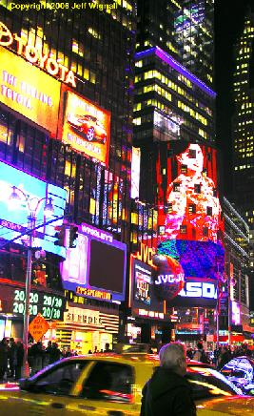
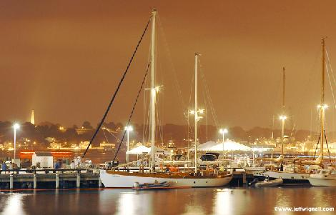
I shot this photo of the New London, Connecticut harbor using a very long 28-second exposure (at f/13) because I wanted to use a low ISO of 200 and because I wanted the natural flow of the water in the harbor to create a smooth sheen. If you look closely at the image you can see a red line going across (just at the water line of the schooner) horizontally--that's the red running light of a power boat that went by during the exposure. The overall color shift of the image is due partly to the "cloudy day" setting of the white balance and partly to the vapor lamps lighting most of the scene. Still, by using a careful curves adjustment, I was able to keep whites white (the boat, the tents, etc.).

Creative Night Photography Technique: Neon signs  Neon signs are one of my absolute favorite subjects--they're bright, they’re colorful and a lot of them are very retro looking which I find fascinating. Photographing neon is incredibly simple because your matrix meter reading is usually very accurate and you can be off by a stop or two and you'll still get great photos. Most neon sings are also bright enough to shoot hand-held if you bump the ISO up to 400 or 800 and turn on the image stabilization. Personally I prefer to use a tripod and shoot at the lowest ISO available, but not everyone is nuts enough to haul a tripod with them to Las Vegas.  One strange little phenomenon you might notice as you photograph neon is that the halation from the tubes will grow or contract based partly on exposure time and the aperture you're using (I tend to use a small aperture of f/22 or smaller, mostly to keep everything in sharp focus). If you see too much of a glow, or too little, try altering your aperture (and your exposure time) and see if it cleans up the image a bit. Also, while I always take an overall shot of the sign, I also take various close-ups and try to create interesting abstract designs from the sign. Since the sign is just sitting there and digital pictures are free, I usually shoot at least several dozen images from different angles and distances, bracketing exposures if I'm not sure how the glow is being recorded. I spent about 20 minutes taking about 50 or 60 shots of the casino sign shown here.
  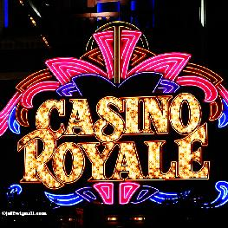
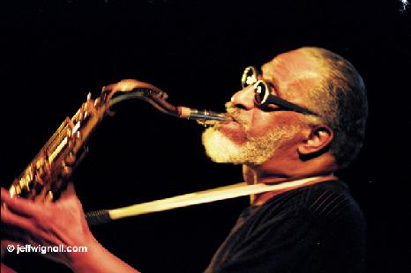
Outdoor night concerts are another great time to flex your night-photo creativity. I photographed sax great Sonny Rollins on the New Haven, Connecticut green. In order to shoot in the dim light I had to raise the ISO to 1600. This shot is not a digital image; it was was shot on slide film and pushed during processing.

 | Creative Technique: Zooming  If you're looking for a fun way to add a twist to your night shots, consider the old "zooming" technique that was so popular back in the film SLR days. It's a simple technique and with digital, of course, you can see the results of your experiments right away. The technique is simple: just set a relatively long exposure (at least 1/15th second) and then zoom the lens from one extreme to the other during the exposure. Of course, the longer the exposure time the more time you have to experiment wiht zoom speed and whether or not you want to use the entire zoom range or just a part of it.  I shot this last summer in Times Square around midnight on a Saturday night. I used a zoom lens (18-70mm Nikkor) and rested the camera on a construction barrier while I zoomed the lens (tele-to-wide) for about a half second at f/13. You can really vary the effect by changing the speed of the "racking" of the zoom and whether you start at the tele or wide range (for some reason that makes quite a difference). Also, if you pause or jiggle the camera, you can get some cool effects. Yes, this is about a 1968 effect :) but it's still fun, especially when you have a subject like Times Square.  There's really no way to predict how your images will turn out and often you get little surprises that you can't anticipate. If you look at the left front edge of the Times Square photo, for example, you can read the "Mamma Mia" sign very clearly. That happened because I must have paused long enough at that particular portion of the frame to register the sign sharply. I also like that you can see faces in the streaks of light (look at the lower left) if you look carefully.
  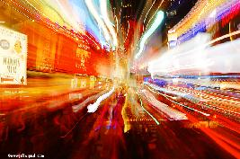
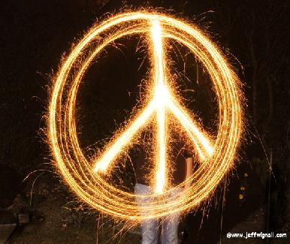
For a step-by-step tutorial on how to make sparkler photos, click the photo.

